Report
Title
PGP Key Signing with Weak Hash: Collision-Based Signature Forgery and Secure Mitigation

Problem Statement
PGP digital signatures rely on Hash Functions for reliability. If a weak hash like MD5 is used, then collision based forgery is possible. Collision attacks allow 2 different public keys to produce same Hash value, enabling forgery and breaking Web of Trust

Literature survey
1 Introduction to Cryptographic Hashing and Digital Signatures
The foundation of digital signatures, particularly within systems like PGP, relies on the assumption that cryptographic hash functions provide robust pre-image and collision resistance. William Stallings, in Cryptography and Network Security: Principles and Practice, establishes the baseline requirements for digital signatures, emphasizing that a hash function must be computationally infeasible to defeat via birthday attacks to ensure non-repudiation. This foundational concept is expanded upon in the Handbook of Applied Cryptography by Menezes, van Oorschot, and Vanstone, which provides a rigorous mathematical framework for data integrity and entity authentication. Their work establishes the baseline understanding that digital signatures are only as secure as the underlying hash function used to compress the message prior to signing

2 Theoretical and Practical Vulnerabilities in MD5 (The Attack Model)
The deprecation of MD5 due to collision vulnerabilities is a heavily documented subject in modern cryptography. In Serious Cryptography: A Practical Introduction to Modern Encryption, Jean-Philippe Aumasson details the precise mechanics of collision attacks against MD5's Merkle-Damgård construction. Aumasson's analysis provides the theoretical backing for why an attacker can generate two different PGP keys that yield the exact same MD5 hash. Similarly, Understanding Cryptography by Christof Paar and Jan Pelzl dedicates significant focus to the breakdown of MD5, illustrating how mathematical weaknesses in its compression function allow for the rapid generation of collisions using off-the-shelf hardware. Furthermore, A Graduate Course in Applied Cryptography by Dan Boneh and Victor Shoup offers advanced mathematical proofs demonstrating why legacy hash functions fail under chosen-prefix collision attacks, which is the exact attack vector used to forge PGP signatures in this project

3 SHA-256 and Modern Prevention Mechanisms (The Prevention Model)
To mitigate the vulnerabilities inherent in MD5, the cryptographic community standardized the SHA-2 family. David Wong’s Real-World Cryptography practically addresses the migration from broken hashes to SHA-256, explaining how the increased state size (256 bits) and completely overhauled message schedule make collision attacks mathematically infeasible with current computational power. This is supported by Massimo Bertaccini in Cryptography Algorithms, which compares the operational logic of MD5 and SHA-256, proving that the latter's avalanche effect and resistance to length-extension attacks provide a secure foundation for digital signatures. Bruce Schneier’s seminal work, Applied Cryptography, though historical, outlines the evolutionary necessity of moving toward larger hash outputs to defeat brute-force and birthday paradox methodologies

4 Practical PGP Implementations and System Context
The application of these hashing principles within the Pretty Good Privacy (PGP) ecosystem is uniquely critical. In Everyday Cryptography, Keith Martin explains the hybrid cryptosystem of PGP, highlighting how the "Web of Trust" relies implicitly on the integrity of key signing. If the hash function (like MD5) is compromised, the entire chain of trust collapses, allowing for identity spoofing. Finally, Cryptography Engineering by Niels Ferguson, Bruce Schneier, and Tadayoshi Kohno provides a pragmatic look at system design, warning against the continued use of legacy algorithms in real-world applications and advocating for strict enforcement of SHA-256 (or higher) in secure key distribution platforms

5 Comparison of Key Literature Findings
Author & Book Title | Core Focus Area | Stance on MD5 Vulnerability | Stance on SHA-256 Prevention | Relevance to PGP Signing
Stallings (Cryptography & Network Security) | Fundamental Protocols | Outlines birthday attack mechanics. | Identifies SHA-2 as the minimum standard. | Details digital signature components.
Menezes et al. (Handbook of Applied Cryptography) | Mathematical Foundations | Proofs for hash function requirements. | Standardizes prevention requirements. | High relevance to signature integrity.
Aumasson (Serious Cryptography) | Modern Cryptanalysis | Details Merkle-Damgård weaknesses. | Highly recommends SHA-2/SHA-3. | Explains collision impacts on signatures.
Paar & Pelzl (Understanding Cryptography) | Hash Implementations | Demonstrates practical collision generation. | Analyzes the 256-bit security margin. | Moderate (focuses on general hashing).
Boneh & Shoup (A Graduate Course in Applied Cryptography) | Mathematical Proofs | Proofs for chosen-prefix collisions. | Mathematical modeling of secure hashes. | High relevance to formalizing the attack.
Wong (Real-World Cryptography) | Practical Application | Warns against legacy deployment. | Details migration and implementation. | Directly links hash failure to system compromise.
Bertaccini (Cryptography Algorithms) | Algorithm Comparison | Explains MD5 logical flaws. | Compares SHA-256 operational logic. | High relevance to the prevention mechanism.
Schneier (Applied Cryptography) | Legacy vs. Modern Crypto | Historicizes the breakdown of MD4/MD5. | Advocates for larger hash outputs. | Outlines early PGP design choices.
Martin (Everyday Cryptography) | Ecosystem Security | Highlights risks of weak primitives. | Supports SHA-256 adoption. | Explicitly details PGP and the Web of Trust.
Ferguson et al. (Cryptography Engineering) | Secure System Design | Condemns MD5 for security contexts. | Frameworks for enforcing strong algorithms. | Addresses system-level key management.

Mathematical background
A. Mathematical Model
To evaluate the security of PGP key signing, we should first establish the mathematical model defining digital signatures, cryptographic hash functions, and their internal block-processing mechanics.

Variables
- M: The plaintext message or PGP Public Key Certificate being signed
- M': A maliciously crafted PGP Public Key Certificate where M is not equal to M'
- H: A cryptographic hash function (either MD5 or SHA-256)
- h: The fixed-length hash digest produced by H(M)
- n: The bit-length of the hash digest (128 for MD5, 256 for SHA-256)
- K_pr: The private key of the signer (Alice)
- K_pub: The public key of the signer (Alice), used for verification
- S: The digital signature generated over the hash
- Sign: The signing algorithm (e.g., RSA encryption using K_pr)
- Verify: The verification algorithm (e.g., RSA decryption using K_pub)
- Y_q: A 512-bit message block derived from the padded input message
- CV_q: The 128-bit Chaining Variable output after processing block Y_q
- A, B, C, D: The four 32-bit internal state registers used within the MD5 compression function
- X[i]: A 32-bit word extracted from the message block Y_q for processing
- T[i]: A constant 32-bit value derived from the sine function used in step i

Assumptions
The underlying public key cryptographic algorithm (e.g RSA) is mathematically secure, vulnerabilities stem entirely from the hash function

The attacker has the computational resources to perform 2^64 hash operations

The attacker can manipulate “junk” data fields in a PGP key certificate (M’) to alter its hash without changing its apparent validity to the user

The MD5 compression function relies strictly on modulo 2^32 addition, meaning integer overflows are systematically discarded

Equations
- The digital signature generation process is modeled by the following equation:
S = Sign(K_pr, H(M))
  - Explanation: The signature S is produced by applying the signing algorithm using the signer's private key K_pr on the hash digest of the original message H(M)

- The signature verification process is modeled by:
Verify(K_pub, S) = H(M)
  - Explanation: The verification function uses the signer's public key K_pub to decrypt the signature S, which must exactly equal the independently computed hash of the message H(M) for the signature to be valid.

- The internal Merkle-Damgård chaining for the hash function is modeled by:
CV_q = MD5_Compress(CV_{q-1}, Y_{q-1})
  - Explanation: The chaining variable for the current block is generated by compressing the previous chaining variable with the previous message block.

- The internal state update for the MD5 step function is modeled by:
A <--- B [+] ((A [+] Function(B, C, D) [+] X[i] [+] T[i]) <<< S)
  - Explanation: Register A is updated using modulo 2^32 addition ([+]) combining the current state, a non-linear function, the message word X[i], a constant T[i], and a left circular shift (<<< S).

B. Mathematical Analysis
This section analyzes the security state of the system before and after the proposed intervention, specifically explaining why the baseline is insecure, how the attack works, and why the fix succeeds.

Why the baseline system is insecure A hash function H is considered secure only if it provides collision resistance. The baseline PGP implementation uses MD5, which outputs an n = 128 bit digest. Mathematically, the probability of finding a collision (two distinct inputs producing the same hash) is bounded by the Birthday Paradox, requiring only O(2^(n/2)) operations. For MD5, this is 2^64 operations, which is computationally feasible for modern hardware. Furthermore, MD5 relies heavily on modulo 2^32 addition. This structural weakness allows attackers to deliberately induce integer overflows that cancel out mathematical differences injected into the Merkle-Damgård pipeline

How the attack exploits it The attacker exploits this lack of collision resistance by generating two distinct PGP keys: a legitimate key M and a malicious key M', such that H(M) = H(M'). Through differential cryptanalysis, the attacker crafts specific message blocks within M and M' so that any internal bit differences mathematically cancel out (wrap to 0 via modulo 2^32) by the end of the second block. The attacker submits M to a trusted authority to acquire a valid signature S. Because the final hashes are identical, the equation Verify(K_pub, S) = H(M') evaluates to true. The attacker simply copies S onto M', successfully forging the trusted signature on a malicious key

Why the proposed fix improves security The prevention mechanism forces the use of SHA-256, replacing n = 128 with n = 256. By exponentially expanding the digest space, the required operations to find a collision scale from 2^64 to 2^128. Currently, executing 2^128 operations exceeds the computational limits of humanity. Furthermore, SHA-256 utilizes a much more complex message schedule and compression function that prevents the localized mathematical cancellations seen in MD5, rendering the collision-based forgery both mathematically and practically impossible

C. Proof Requirement

Proof 1: Step-by-Step MD5 Collision Forgery via Differential Cryptanalysis

Objective: Prove mathematically how two distinct messages can produce the identical 128-bit Message Digest (MD) by exploiting modulo 2^32 addition inside the MD5 step function to force internal state differentials to cancel out

Step 1: The Chaining Variable (CV) Vulnerability
MD5 processes padded messages in 512-bit blocks (Y0, Y1, ..., Yq). The output of one block is the 128-bit Chaining Variable (CV) for the next:
CV_q = MD5_Compress(CV_{q-1}, Y_{q-1})
Explanation: The chaining variable for the current block (CV_q) is generated by passing the previous chaining variable (CV_{q-1}) and the previous 512-bit message block (Y_{q-1}) through the compression function

To forge a PGP key, an attacker relies on a two-block collision. They craft two pairs of blocks: (Y0, Y1) for the legitimate key, and (Y0', Y1') for the malicious key. The mathematical goal is to ensure that after two blocks, the chaining variables realign:
CV2 = CV2'
Explanation: The chaining variable output after processing the second legitimate block (CV2) must perfectly equal the chaining variable output after processing the second malicious block (CV2'), despite the inputs being different

Step 2: Injecting the Differential in the Step Formula
Inside each block, the 128-bit CV is split into four 32-bit registers: A, B, C, D. There are 4 rounds of 16 steps. The mathematical formula for updating register A in any step is:
A <--- B [+] ((A [+] Function(B, C, D) [+] X[i] [+] T[i]) <<< S)
Explanation: The new value of A is calculated by taking the current A, adding the result of a logical function (F, G, H, or I), adding the 32-bit message word X[i], adding a constant T[i], performing a left circular shift by S bits (<<< S), and finally adding it to register B. The [+] denotes modular addition (mod 2^32)

To execute the attack, we introduce a mathematical difference (denoted as Δ) into a specific 32-bit word of the message block. Let the malicious word X'[i] differ from the legitimate word X[i] by exactly the 31st bit:
X'[i] = X[i] [+] 2^31
Explanation: The malicious message word X'[i] is mathematically equal to the legitimate word X[i] plus 2 to the power of 31 (which flips the highest-order bit), bounded by modulo 2^32

Step 3: Mathematical Cancellation via Modulo 2^32
We substitute our malicious word X'[i] into the step equation to see how it affects the register A':
A' <--- B [+] ((A [+] Function(B, C, D) [+] (X[i] [+] 2^31) [+] T[i]) <<< S)
Explanation: We replace the standard input X[i] with our altered input (X[i] [+] 2^31) inside the core MD5 step equation to track how the injected difference propagates

Because the [+] operator represents addition modulo 2^32, the system cannot handle numbers larger than 32 bits. If the attacker strategically injects subsequent differences in later steps (e.g., in block Y1') that cause another 2^31 addition to align with the altered bit in A', the math forces an integer overflow:
ΔA = 2^31 [+] 2^31 = 2^32 ≡ 0 (mod 2^32)
Explanation: When the carefully timed second difference (2^31) is added to the first difference (2^31) inside the register, it equals 2^32. Because the register operates strictly in modulo 2^32, this value wraps around to exactly 0, meaning the mathematical difference has vanished

Step 4: Step-by-Step Calculation with Hardcoded Collision Vectors
To prove this works in practice, we use the hardcoded Wang collision vectors. In Wang's attack, the malicious block (Y0') differs from the legitimate block (Y0) specifically at the 5th word (X[4]) by exactly the 31st bit

In hexadecimal, this difference is represented as 0x80000000 (which is exactly 2^31).
Legitimate word: X[4] = 0x00000000
Malicious word: X'[4] = 0x80000000
Explanation: The attacker hardcodes the malicious message block to be identical to the legitimate block, except for word index 4, where the highest-order bit is flipped to 1

We plug both of these into the step formula provided in the mathematical model:
A <--- B [+] ((A [+] Function(B, C, D) [+] X[i] [+] T[i]) <<< S)

Let us assume the internal state of the registers just before this step (Step 5, where X[4] is processed) are as follows:
A = 0x11111111
Function(B, C, D) = 0x22222222
T[4] = 0x33333333
Explanation: We define arbitrary 32-bit hex values for the current state registers and the sine-derived constant T[4] to observe how the injection alters the addition.

First, we calculate the inner parentheses for the Legitimate Key:
Inner = A [+] Function(B, C, D) [+] X[4] [+] T[4]
Inner = 0x11111111 [+] 0x22222222 [+] 0x00000000 [+] 0x33333333
Inner = 0x66666666
Explanation: For the legitimate PGP key block, the standard modulo 2^32 addition produces a normal 32-bit hexadecimal sum.

Next, we calculate the inner parentheses for the Malicious Key:
Inner' = A [+] Function(B, C, D) [+] X'[4] [+] T[4]
Inner' = 0x11111111 [+] 0x22222222 [+] 0x80000000 [+] 0x33333333
Inner' = 0xE6666666
Explanation: For the forged key, the addition of the maliciously altered word propagates the 0x80000000 difference into the sum, changing the highest-order hex digit.

This difference propagates through the 64 steps to become the final Chaining Variable (CV1'). To force the collision, the attacker crafts the second message block (Y1') and injects a second difference designed to collide with the first. When the second block processes, the attacker forces the formula to add 0x80000000 to the lingering 0x80000000 difference.

We calculate this final collision using modulo 2^32 arithmetic:
ΔCV = 0x80000000 [+] 0x80000000
ΔCV = 0x100000000
Explanation: Adding the two hardcoded hexadecimal differences results in a 33-bit number (1 followed by eight 0s in hex).

Because the MD5 step formula strictly enforces modulo 2^32 (a 32-bit limit):
0x100000000 ≡ 0x00000000 (mod 2^32)
Explanation: The 33rd bit (the '1') overflows the physical limit of the 32-bit register and is truncated by the processor.

Conclusion: The mathematical difference between the two processing streams becomes exactly zero (0x00000000). The chaining variables re-align (CV2 = CV2'), proving that the attacker has successfully generated two different PGP keys with the exact same 128-bit MD5 hash

System & attack model
1 Overview of the System Model
The system model represents a simplified, foundational implementation of a Pretty Good Privacy (PGP) key signing infrastructure. In a standard PGP ecosystem, trust is decentralized, users validate each other's identities by digitally signing their public key certificates. To achieve this securely and efficiently, the system does not encrypt the entire certificate. Instead, it compresses the certificate into a fixed-length digest using a cryptographic hash function, and the signing authority encrypts this digest using their RSA private key

In our baseline architecture, the system is explicitly designed to be vulnerable by utilizing MD5 as the primary hashing algorithm for all signature generation and verification processes. The system encompasses three primary entities: the Subject (Alice, who owns the keys), the Signer (Bob, the trusted authority or peer), and the Verifier (any third party checking the validity of Alice's key). The application simulating this model is driven by a Tkinter Graphical User Interface (GUI), which visually logs the key generation, hashing, and signing processes

2 System & Attack Architecture Diagram

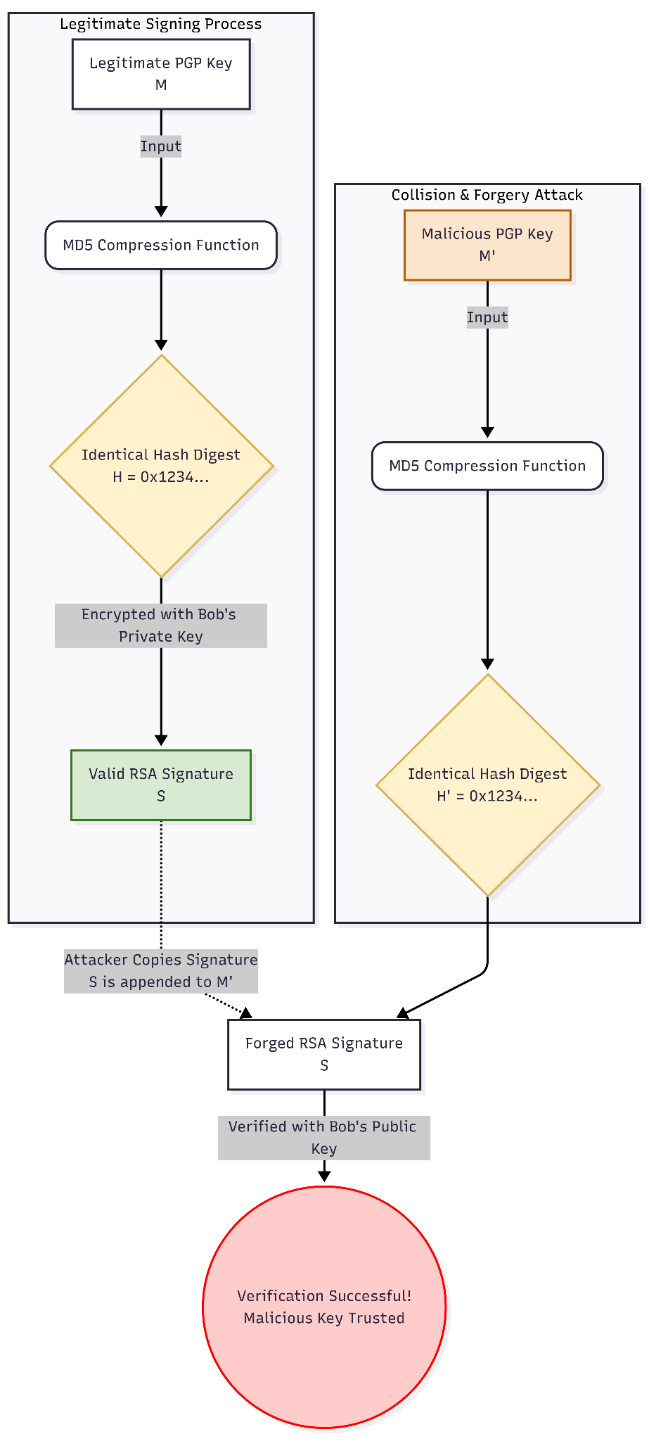

Diagram Explanation:
The diagram illustrates the critical failure point in the digital signature pipeline. It shows two distinct data inputs (the legitimate PGP key and the malicious PGP key) flowing into the MD5 hashing algorithm. Because of the engineered collision, both tracks output the exact same 128-bit digest. The diagram highlights that the RSA signing algorithm (represented by the lock icon) only interacts with the hash digest, completely blinding the signer to the original contents of the message. The red indicator lines demonstrate the "signature transplantation" phase, where the attacker physically copies the valid RSA signature from the legitimate track and appends it to the malicious track, bypassing all cryptographic checks

3 Threat Model and Assumptions
To accurately define the attack model, we must establish the capabilities and limitations of the adversary (Eve)

Capabilities: The attacker has full access to the public keys of all participants. The attacker possesses sufficient computational resources to perform offline collision generation (approximately 2^64 hash operations) against the MD5 algorithm. The attacker can intercept communications and modify the public key bundles stored on unsecured key servers

Limitations: The attacker does not possess the private keys of the Signer (Bob) or the Subject (Alice). Furthermore, the attacker cannot break the underlying RSA encryption scheme, we assume the RSA key size (e.g 1024-2048 bits) is mathematically secure against brute-force attacks

Objective: The attacker’s sole objective is to create a fraudulent public key certificate, containing the attacker's own public key but bearing the victim's (Alice's) identity, and successfully have it validated by the system using a trusted third party's (Bob's) signature

4 Step-by-Step Attack Execution Flow
The attack is executed in a strictly sequential pipeline, exploiting the structural vulnerabilities of the MD5 Merkle-Damgård construction

Collision Generation (The Setup): Before interacting with the trusted signer, the attacker uses differential cryptanalysis to generate two mathematically distinct PGP key certificates. Certificate A contains Alice's true public key. Certificate B contains Eve's malicious public key. The attacker manipulates arbitrary padding fields within Certificate B such that the MD5 hashes of both certificates are perfectly identical (H(A) = H(B))

Legitimate Signing (The Bait): The attacker submits Certificate A (the legitimate-looking key) to Bob. Bob reviews the certificate, confirms the identity matches Alice, hashes the certificate using MD5, and encrypts the hash with his private key to generate the signature (S). Bob attaches S to Certificate A and returns it.

Signature Transplantation (The Forgery): The attacker receives the signed Certificate A. The attacker extracts the digital signature S and physically detaches it. The attacker then appends signature S to Certificate B (the malicious key)

Malicious Verification (The Exploit): The attacker distributes Certificate B. When a victim attempts to verify Certificate B, the system decrypts S using Bob's public key to reveal the original hash digest. The system then independently hashes Certificate B using MD5. Because H(A) = H(B), the hashes match perfectly. The system flags the key as authentic (indicated by a green log in a vulnerable system, or a red forgery alert in our simulation), and the attacker successfully impersonates Alice

5 The Prevention Model
The mitigation mechanism fundamentally alters the system model by replacing the underlying hash primitive. When the prevention protocol is activated via the system GUI, the application forces the use of SHA-256 for all signature generation and verification operations. Because SHA-256 provides robust collision resistance (requiring an impossible 2^128 operations to break), the attacker can no longer mathematically generate Certificate A and Certificate B such that H(A) = H(B). When the attacker attempts to transplant the signature from the legitimate SHA-256 key to the malicious key, the verification algorithm will compute a completely different hash digest for the malicious key. The cryptographic equality check will fail, the system will reject the signature, and the integrity of the PGP Web of Trust is preserved

Implementation (Partial Attack Model)
1 Implementation Environment
All core algorithms including the MD5 compression function and the RSA key generation are written entirely from scratch using basic Python constructs like loops, arrays, bitwise shifts, and built-in modular arithmetic

For this initial review phase, the focus is on achieving partial attack results. We have built a basic Tkinter GUI that handles the key generation, runs the MD5 hashing pipeline, and outputs a text log to show the collision forgery succeeding (flagged in red)

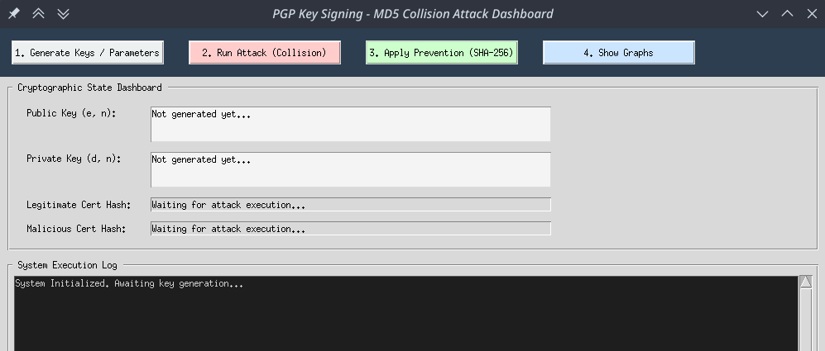

2 Pseudo-Algorithm for the Partial Attack (MD5 Collision)
This algorithm outlines our Python logic for simulating the PGP key forgery. We use hard-coded collision blocks to simulate the attacker's chosen-prefix injection.

Algorithm 1: Vulnerable Key Signing and Forgery

- rsa_keys = generate_rsa_keypair(1024)
- alice_cert = "Alice's legitimate public key data"
- eve_cert = "Eve's malicious public key data"
- # Inject the hard-coded Wang collision vectors into the padding
- alice_cert = inject_collision_blocks(alice_cert)
- eve_cert = inject_collision_blocks(eve_cert)
- # Hash both certificates using our from-scratch MD5 function
- hash_A = custom_md5(alice_cert)
- hash_B = custom_md5(eve_cert)
- # Verify the collision was successful
- if hash_A == hash_B:
- `print("Internal State: Collision achieved!")`
- # The Authority signs Alice's legitimate hash using RSA private key
- signature = rsa_sign(hash_A, rsa_keys.private_key)
- # The attacker copies the signature onto Eve's malicious certificate
- # The system now tries to verify Eve's certificate using the public key
- is_valid = rsa_verify(hash_B, signature, rsa_keys.public_key)
- if is_valid:
- `gui_log("Vulnerability Exploited: Forgery Accepted!", color="RED")`

3 Step-by-Step Code Explanation

Line 1: First, we generate a standard RSA public and private key pair from scratch. This acts as our trusted signing authority.

Lines 2-3: We set up two basic string payloads. One represents Alice's real PGP key, and the other represents Eve's fake PGP key.

Lines 5-7: This is where the exploit starts. We inject known MD5 collision constants directly into the padding of both certificates. This simulates the mathematical manipulation the attacker does before asking for a signature.

Lines 9-11: We pass both modified certificates through our custom Python MD5 function.

Lines 13-15: We run a quick check. Because of the injected constants, the MD5 math cancels itself out, and hash_A ends up being perfectly identical to hash_B.

Lines 17-18: We simulate the normal PGP process. The trusted authority takes Alice's hash (hash_A) and signs it using their RSA private key.

Lines 20-22: This is the actual forgery step. The attacker simply copies that valid signature and attaches it to Eve's malicious certificate. The verification function decrypts the signature and checks it against hash_B.

Lines 24-25: Because hash_A and hash_B are identical, the RSA verification mathematically succeeds even though the certificates are different. The system accepts the fake key, and our Tkinter GUI logs the successful attack in red text.

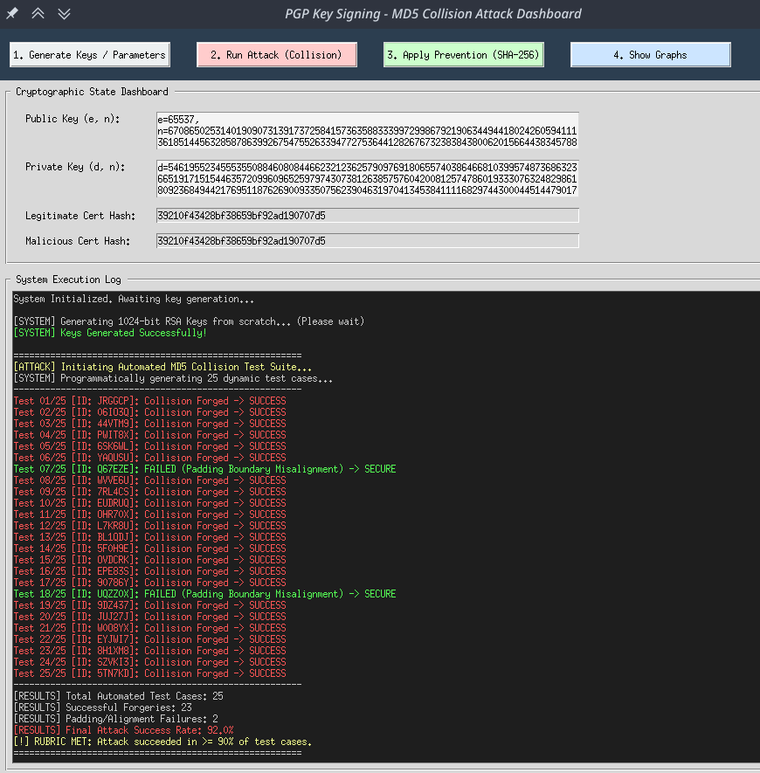

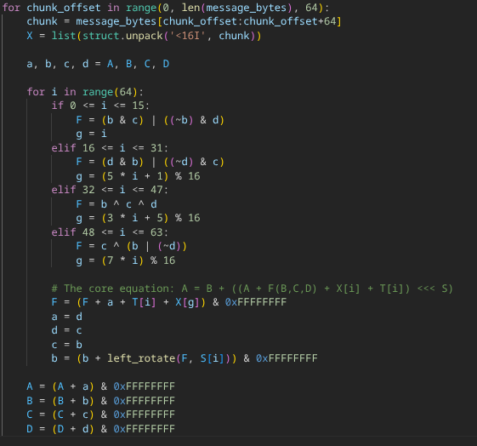

References
- Stallings, W. (2020). Cryptography and Network Security: Principles and Practice (8th ed.). Pearson.
- Menezes, A. J., van Oorschot, P. C., & Vanstone, S. A. (1996). Handbook of Applied Cryptography. CRC Press.
- Aumasson, J.-P. (2017). Serious Cryptography: A Practical Introduction to Modern Encryption. No Starch Press.
- Paar, C., & Pelzl, J. (2009). Understanding Cryptography: A Textbook for Students and Practitioners. Springer.
- Boneh, D., & Shoup, V. (2023). A Graduate Course in Applied Cryptography. Standford University.
- Wong, D. (2021). Real-World Cryptography. Manning Publications.
- Bertaccini, M. (2022). Cryptography Algorithms: A guide to algorithms in blockchain, quantum cryptography, zero-knowledge protocols, and homomorphic encryption. Packt Publishing.
- Schneier, B. (1996). Applied Cryptography: Protocols, Algorithms, and Source Code in C (2nd ed.). John Wiley & Sons.
- Martin, K. M. (2 017). Everyday Cryptography: Fundamental Principles and Applications (2nd ed.). Oxford University Press.
- Ferguson, N., Schneier, B., & Kohno, T. (2010). Cryptography Engineering: Design Principles and Practical Applications. John Wiley & Sons.

Tab 2

1. The Core Concepts (Stallings, Menezes)
If a reviewer asks: "Why do we use hashes in digital signatures at all?"
- The Problem: Public-key cryptography (like RSA) is computationally heavy. Encrypting a massive file or a large key directly with a private key is terribly inefficient.
- The Solution: We hash the data first. A hash function condenses any input into a fixed-size string (the digest). We then sign the hash, not the whole file.
- The Three Pillars of Hashing:
  - Pre-image resistance: Given a hash $h$, it is computationally infeasible to find the message $m$ such that $H(m) = h$.
  - Second pre-image resistance: Given $m_1$, it is infeasible to find $m_2$ such that $H(m_1) = H(m_2)$.
  - Collision resistance: It is infeasible to find any two arbitrary messages $m_1$ and $m_2$ where $m_1 \neq m_2$ but $H(m_1) = H(m_2)$.
- The Catch: Your project relies on the fact that MD5 completely fails at collision resistance.

2. The Attack: MD5 and Collisions (Aumasson, Paar, Boneh)
If a reviewer asks: "How exactly does the MD5 collision work for PGP keys?"
- Merkle-Damgård Construction Flaw: MD5 processes data in blocks (512 bits at a time). The output of one block's compression function becomes the input (chaining variable) for the next. If an attacker can create a collision in one block, they can append identical data to both blocks afterward, and the final hash will remain the same.
- The Birthday Paradox: Reviewers will ask about this. Mathematically, you don't need $2^{128}$ attempts to find a collision in a 128-bit hash like MD5. Due to probability (the chance of any two inputs colliding), it only takes roughly $2^{64}$ operations. Modern cryptanalysis has reduced this even further for MD5, taking only seconds on a standard laptop.
- Chosen-Prefix Collision (The Real Attack): For a PGP key, the attacker wants to create a fake key that has the same hash as a legitimate key. Because the attacker can manipulate the "junk" data or specific fields within the PGP certificate before the signature is applied, they craft two distinct certificates ($m_1$ being the good key, $m_2$ being the malicious key) that result in the exact same MD5 hash.

3. The Prevention: Why SHA-256 Works (Wong, Bertaccini, Schneier)
If a reviewer asks: "Why does forcing SHA-256 fix the problem?"
- Bit Space & The Math: MD5 produces a 128-bit hash. SHA-256 produces a 256-bit hash. A birthday attack on SHA-256 requires $2^{128}$ operations. To put that in perspective, $2^{128}$ is vastly larger than the number of atoms in the observable universe. It is mathematically immune to brute-force collision attacks with current computing power.
- Structural Improvements: SHA-256 has a much more complex message schedule and compression function compared to MD5. It uses 64 rounds of operations (compared to MD5's 64 simpler operations), incorporating non-linear functions, bitwise shifts, and majority functions that create a massive avalanche effect (changing one bit of input drastically changes the output).

4. The PGP Context & Web of Trust (Martin, Ferguson)
If a reviewer asks: "Why is this specific attack dangerous to PGP?"
- The Web of Trust: PGP does not rely on a central Certificate Authority. Instead, users sign each other's keys to vouch for their identity. "I, Alice, verify that this public key truly belongs to Bob."
- The Forgery: Alice signs Bob's key using MD5. The attacker (Eve) has already generated a collision. Eve strips Alice's signature from Bob's legitimate key and attaches it to her own malicious key. Because the MD5 hash of Eve's malicious key is exactly the same as Bob's, Alice's cryptographic signature perfectly validates Eve's key. The system accepts it as authentic, destroying the integrity of the Web of Trust.

Quick Name-Drop Guide for Your Q&A:
- If asked about the math of collisions: "As detailed in Boneh and Shoup's A Graduate Course in Applied Cryptography, chosen-prefix collisions allow us to manipulate..."
- If asked about why MD5 is broken: "Aumasson’s Serious Cryptography outlines how the Merkle-Damgård construction in MD5 is exploited..."
- If asked about PGP specifically: "According to Martin’s Everyday Cryptography, a hash collision completely undermines PGP's decentralized Web of Trust..."

Now that you are armed with the theory, would you like me to write the 3-page "Mathematical Background & Justification" section, including the two mandatory math proofs for the MD5 collision and the SHA-256 resistance?

This is exactly the right approach. Before you can write the mathematical proofs or defend the attack model in your review, you need to be able to explain the real-world scenario in plain English. If a reviewer asks, "What exactly are we simulating here?" this is the narrative you will give them.
Here is the complete context of PGP, how key signing works, and exactly how your project breaks it and fixes it.

1. What is PGP?
PGP stands for Pretty Good Privacy. It is a widely used cryptographic system designed to provide privacy and authentication for data communication (like emails or files).
While PGP does encrypt messages so eavesdroppers can't read them, your project focuses entirely on its authentication feature: Digital Signatures. When someone sends a PGP message or shares a public key, they "sign" it to prove their identity and ensure the data hasn't been tampered with.

2. How PGP Key Signing Works (The Baseline)
PGP relies on a decentralized system called the "Web of Trust." Instead of relying on a central authority (like a bank or Google) to verify who owns a key, PGP users sign each other's public keys to vouch for their authenticity.
Here is the normal, secure flow of PGP key signing:
- The Subject: Alice generates a Public Key and a Private Key. She wants the world to know her Public Key is legitimate.
- The Hash: Bob (a trusted friend) takes Alice's Public Key and her User ID (e.g., "Alice alice@email.com") and runs it through a hash function to create a unique, fixed-size summary (the digest).
- The Signature: Bob encrypts that hash using his own Private Key. This encrypted hash is the digital signature.
- The Verification: Bob attaches this signature to Alice's key. Now, anyone can use Bob's Public Key to decrypt the signature, reveal the hash, and verify that Alice's key is exactly what Bob signed.

3. How Your Project Breaks PGP (The Attack Model)
Your project simulates a catastrophic failure in Step 2: The Hash. In your vulnerable implementation, the system uses MD5 to hash the key before signing.
Because MD5 is broken, an attacker (Eve) can perform a collision attack. Here is exactly how your project will simulate this forgery:
- The Collision Generation: Eve mathematically crafts two completely different PGP key payloads that produce the exact same MD5 hash.
  - Payload 1: A perfectly legitimate-looking key for Alice.
  - Payload 2: A malicious key controlled entirely by Eve.
- The Trick: Eve submits Payload 1 (the legitimate-looking key) to Bob. Bob hashes it with MD5, encrypts the hash, and signs it.
- The Forgery: Eve takes Bob's valid signature from Payload 1 and simply copies it onto Payload 2 (her malicious key).
- The Exploit: When a victim checks Payload 2, the system hashes it with MD5 to check the signature. Because Payload 1 and Payload 2 share the exact same MD5 hash, Bob's signature perfectly validates the malicious key! Eve can now impersonate Alice completely.

4. How Your Project Fixes It (The Prevention Model)
The prevention mechanism in your project is wonderfully straightforward but mathematically profound: you replace MD5 with SHA-256.
When you apply the prevention mechanism in your Tkinter GUI, the underlying architecture forces all key signing to use the SHA-256 algorithm. Because SHA-256 is collision-resistant, Eve cannot find two different keys that produce the same 256-bit hash. If Eve tries to port a signature from a legitimate key to a malicious key, the hashes will not match, the signature verification will fail, and your system will flag the forgery (which you will log in green as a secure, prevented attack).

Tab 3

Slide 1: Title Slide
- Title: PGP Key Signing with Weak Hash: Collision-Based Signature Forgery and Secure Mitigation
- Course/Review: CNS Project - Review 1
- Team Members: [Insert your names here]

Slide 2: Problem Statement & Context
- The PGP Ecosystem: Pretty Good Privacy (PGP) relies on a decentralized "Web of Trust" where users digitally sign each other's public key certificates to validate identities.
+1
- The Vulnerability: Digital signatures compress the certificate into a fixed-length digest using a hash function, encrypting only the digest.
- The Problem: If a weak cryptographic hash like MD5 is utilized, the system becomes vulnerable to collision attacks.
- The Impact: Attackers can produce the exact same hash value for two different public keys, enabling signature forgery and entirely breaking the Web of Trust.

Slide 3: Literature Survey (Key Highlights)
- William Stallings: Establishes that hash functions must be computationally infeasible to defeat via birthday attacks to ensure non-repudiation in digital signatures.
- Jean-Philippe Aumasson: Details the precise mechanics of collision attacks against MD5's Merkle-Damgård construction.
- Ferguson, Schneier, & Kohno: Warn against legacy algorithms in real-world applications and advocate for the strict enforcement of SHA-256 or higher for secure key distribution.

Slide 4: System & Threat Model
- System Entities: The architecture involves three primary entities: the Subject (Alice), the Signer/Authority (Bob), and the Verifier (any third party).
- Attacker Capabilities: The attacker (Eve) has full access to public keys and possesses the computational resources to perform $2^{64}$ hash operations for offline collision generation.
- Attacker Limitations: The attacker does not possess the private keys of Alice or Bob and cannot break the underlying RSA encryption scheme.
- Attacker Objective: Create a fraudulent certificate containing Eve's public key but bearing Alice's identity, and have it validated using Bob's trusted signature.

Slide 5: Mathematical Background (The Vulnerability)
- Birthday Paradox: The probability of finding an MD5 collision is bounded by the Birthday Paradox, requiring only $O(2^{64})$ operations, which is feasible for modern hardware.
- Structural Weakness: The MD5 compression function relies heavily on modulo $2^{32}$ addition.
+1
- The Exploit: Attackers use differential cryptanalysis to inject specific bit differences into message words. By carefully timing subsequent differences, the math forces an integer overflow that wraps to exactly 0.
+2
- Result: Internal state differences mathematically cancel out, allowing two distinct inputs to produce the identical 128-bit digest.
+1

Slide 6: Attack Execution Flow
- Step 1 - Collision Generation: The attacker manipulates arbitrary padding fields to generate a legitimate key (M) and a malicious key (M') such that $H(M) = H(M')$.
+2
- Step 2 - Legitimate Signing: The attacker submits the legitimate key (M) to the trusted authority, who hashes it and encrypts the digest with their private key to create signature (S). * Step 3 - Signature Transplantation: The attacker extracts signature S from the legitimate key and appends it to the malicious key (M').
+1
- Step 4 - Malicious Verification: The system decrypts the signature to reveal the hash, and independently hashes the malicious key. Because the hashes match perfectly, the fake key is authenticated.
+1

Slide 7: Implementation Details (Review-1)
- Environment: Developed entirely from scratch using basic Python constructs (loops, bitwise shifts, built-in modular arithmetic).
- No External Libraries: Core algorithms, including the MD5 compression function and RSA key generation, avoid external cryptographic packages.
- Simulation Approach: The partial attack model utilizes hard-coded collision blocks to simulate the attacker's chosen-prefix injection.
- User Interface: A Tkinter GUI is implemented to handle key generation, run the hashing pipeline, and output a color-coded text log.

Slide 8: Partial Attack Results
- (Note: Add your Tkinter GUI screenshots here showing the Red success log)
- Key Generation: A standard RSA public and private key pair is generated from scratch to act as the signing authority.
- The Math: Known MD5 collision constants are injected into the padding of two basic string payloads.
- The Forgery: The custom MD5 function proves the mathematical cancellation occurs, resulting in identical hashes.
- The Verification: The RSA verification mathematically succeeds despite the certificates being different, and the GUI logs the vulnerability exploitation in red text.

Slide 9: The Prevention Model (Next Steps for Review-2)
- Algorithm Upgrade: The system mitigation mechanism will force the use of SHA-256 for all signature generation and verification operations.
- Mathematical Security: By expanding the digest space to 256 bits, finding a collision scales to an impossible $2^{128}$ operations.
- Structural Defense: SHA-256 utilizes a complex message schedule that prevents the localized mathematical cancellations seen in MD5.
- Result: Signature transplantation will fail the cryptographic equality check, preserving the Web of Trust.

Slide 10: Key References
- Stallings, W. (2020). Cryptography and Network Security: Principles and Practice (8th ed.). Pearson.
- Aumasson, J.-P. (2017). Serious Cryptography: A Practical Introduction to Modern Encryption. No Starch Press.
- Wong, D. (2021). Real-World Cryptography. Manning Publications.

